MEET Y1 Day 6 Lab 2: Loops!

While Loops and Graphics
1. Last week you learned how to draw images like this one with Turtle. Now let’s make more complex shapes and patterns using "while" loops.

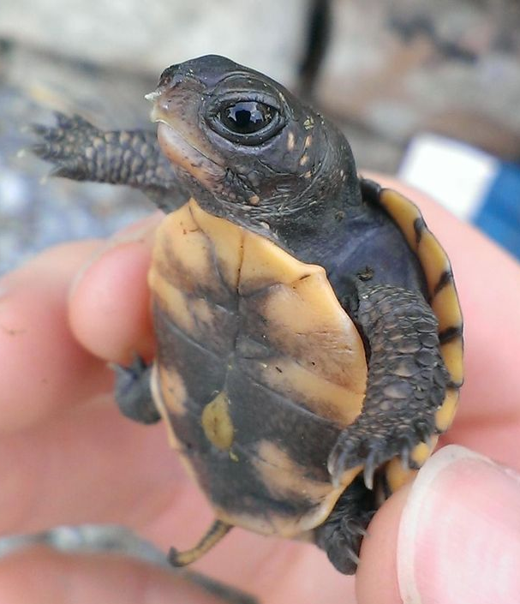

Make a new file called maths_plots.py and copy the code below:
import turtle

x = 0
while x<300:
y = x**2/300 #x**2 is the same as x*x
turtle.goto(x, y)
x = x + 1

turtle.mainloop()

We made a graph of a math function!
How many times does the loop repeat? 300
Now change the last line to x = x + 100
What do you think will happen to the graph?
Get shorter
Now how many times does the loop repeat? 3

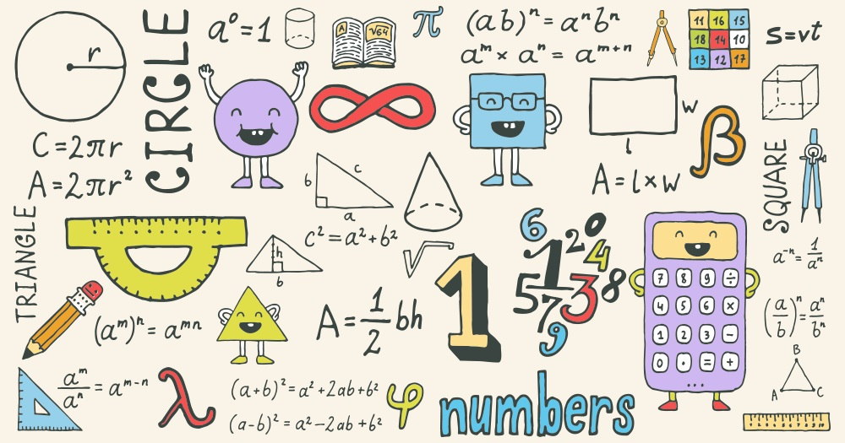

For Loops
2. Make a new program and call it "turtleshapes.py". Let"s use a for loop to draw something! Try this:

import turtle

num_pts = 5 #number sides to your drawing!
for i in range(num_pts):
turtle.left(360/num_pts)
turtle.forward(100)

turtle.mainloop()

We drew a pentagon!!!
How many times does the loop repeat? 5
What does the function range(num_pts) do? 0,1,2,3,4 (range (5))
Try increasing the number of sides to your shape.

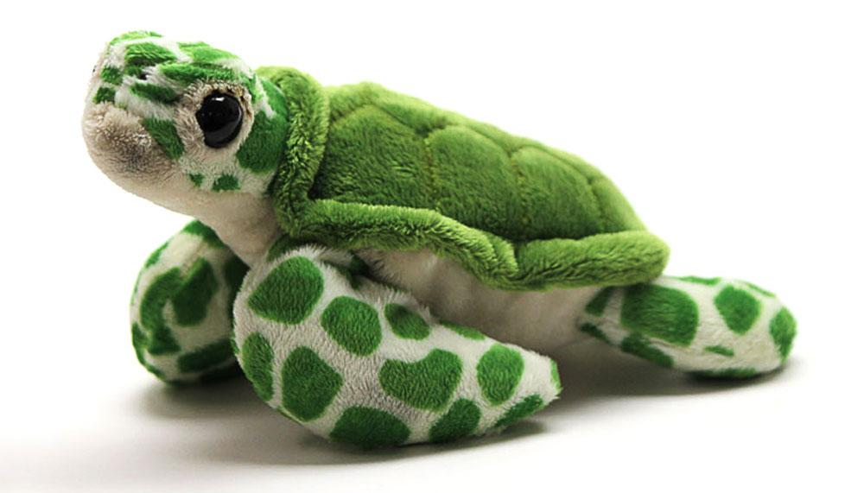

FIZZBUZZ!
Open a new file and name it "fizzbuzz.py".

Get your script to print numbers from 1 to 100!

If a number is divisible by 3, instead of printing the number, print "fizz"!

If a number is divisible by 5, instead of printing the number, print "buzz"!

If it is divisible by 5 and 3, print "fizzbuzz"!

Start by printing the numbers 1 to 100:

for i in range(100):
count = i + 1
print(count)

If the number is divisible by 3, print "fizz" instead:

for i in range(100):
count = i + 1
if count % 3 == 0:
print("fizz")
else:
print(count)

If the number is divisible by 5, print "buzz" instead:

for i in range(101):
count = i + 1
if count % 3 == 0:
print("fizz")
elif _________:
print("buzz")
else:
print(count)
If the number is divisible by 3 and 5, print "fizzbuzz"!

Bonus Extension:
Now rather than printing the numbers, why not make the user provide an input? If the input is wrong, then the program should print "Sorry! Wrong answer!" and end the loops!

Hint: Inputs would be either an integer, "fizz", "buzz", "fizzbuzz". You will need to ask your TA how to end a loop!



Extra stretch:
Open a new file and name it "factorise.py"

Get your code to print all the prime factors of 150.

Note: Prime factors are all the prime numbers that multiply to 150. Try solving it by hand first!

Can you extend your code to factorize any number less than 200?

An example for the number 144:

